

**Tips for WebEx Participants**

**First time users**: it is recommended that you login 5-10 minutes prior to the session start time as you will need to download the app and let it run on your computer before you’re able to join the meeting

**AUDIO**

You will have the option of joining audio via the computer or phone. It is strongly recommended to use a phone if one is available to you. Computer audio users tend to hear a lot of feedback. (Be sure to mute yourself either way)

**ADDITIONAL TOOLS**

Additional tools can all be accessed by hovering your mouse over the toggle at the top middle of your screen once you’re logged into the meeting:

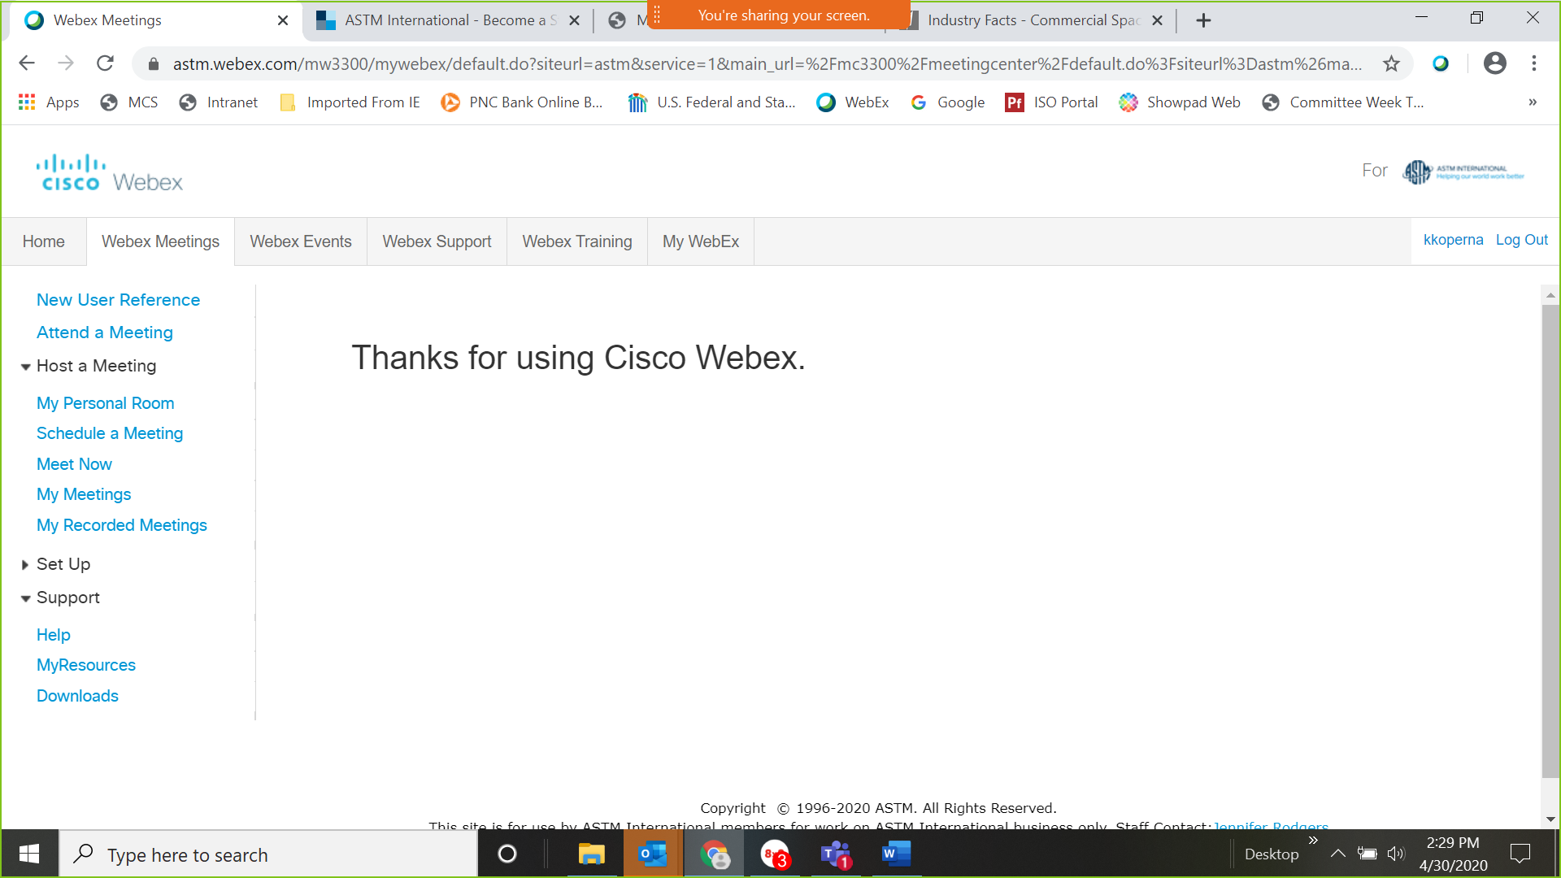

Once you hover over the toggle on the top middle, it will open a drop down with a listing of all the tools:

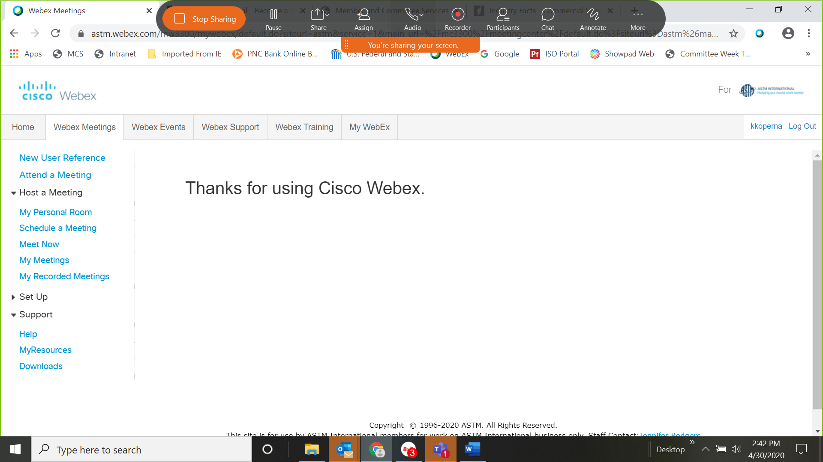

**MEETING PARTICIPANTS** – if you do not see the list of participants automatically on the right of the presenting screen, select the participant option from the drop down. This will open a dialogue box of all participants (show below)



Dialogue box appears that lists all meeting participants

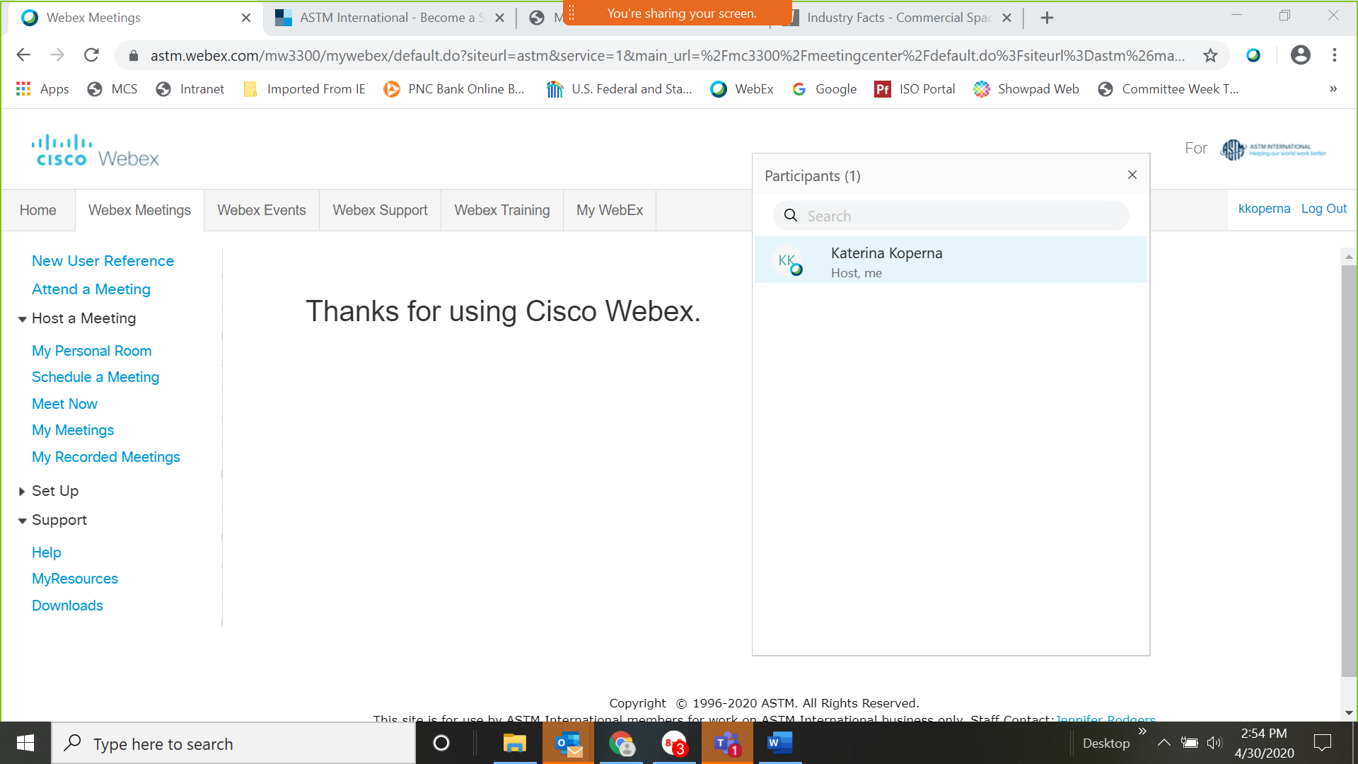

**CHAT FEATURE –** can be used to pose questions to the presenter, chat with other participants privately or send a message to all participants (chat recipients can be changed by using drop down). Chat should also appear automatically at the bottom of the participant box or may appear in the bottom middle of the presenters screen.



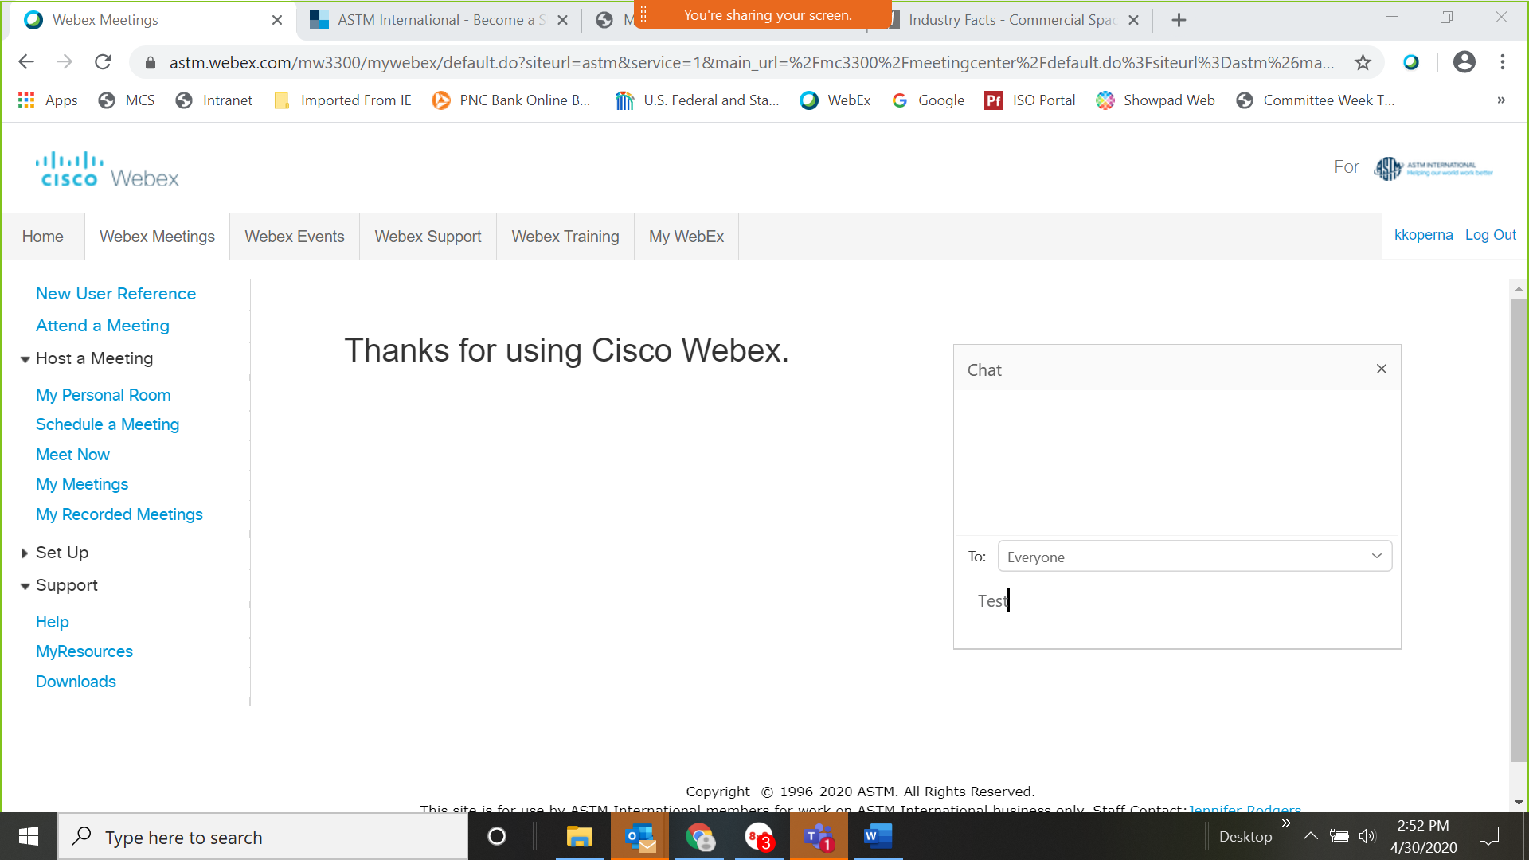

Use arrow to change recipient of chat

Type your message here (clicking “enter” sends message)

**RAISE YOUR HAND TOOL –** available at the bottom of the participant box or by clicking the hand next to your name in the participant box (depending on WebEx host setup)

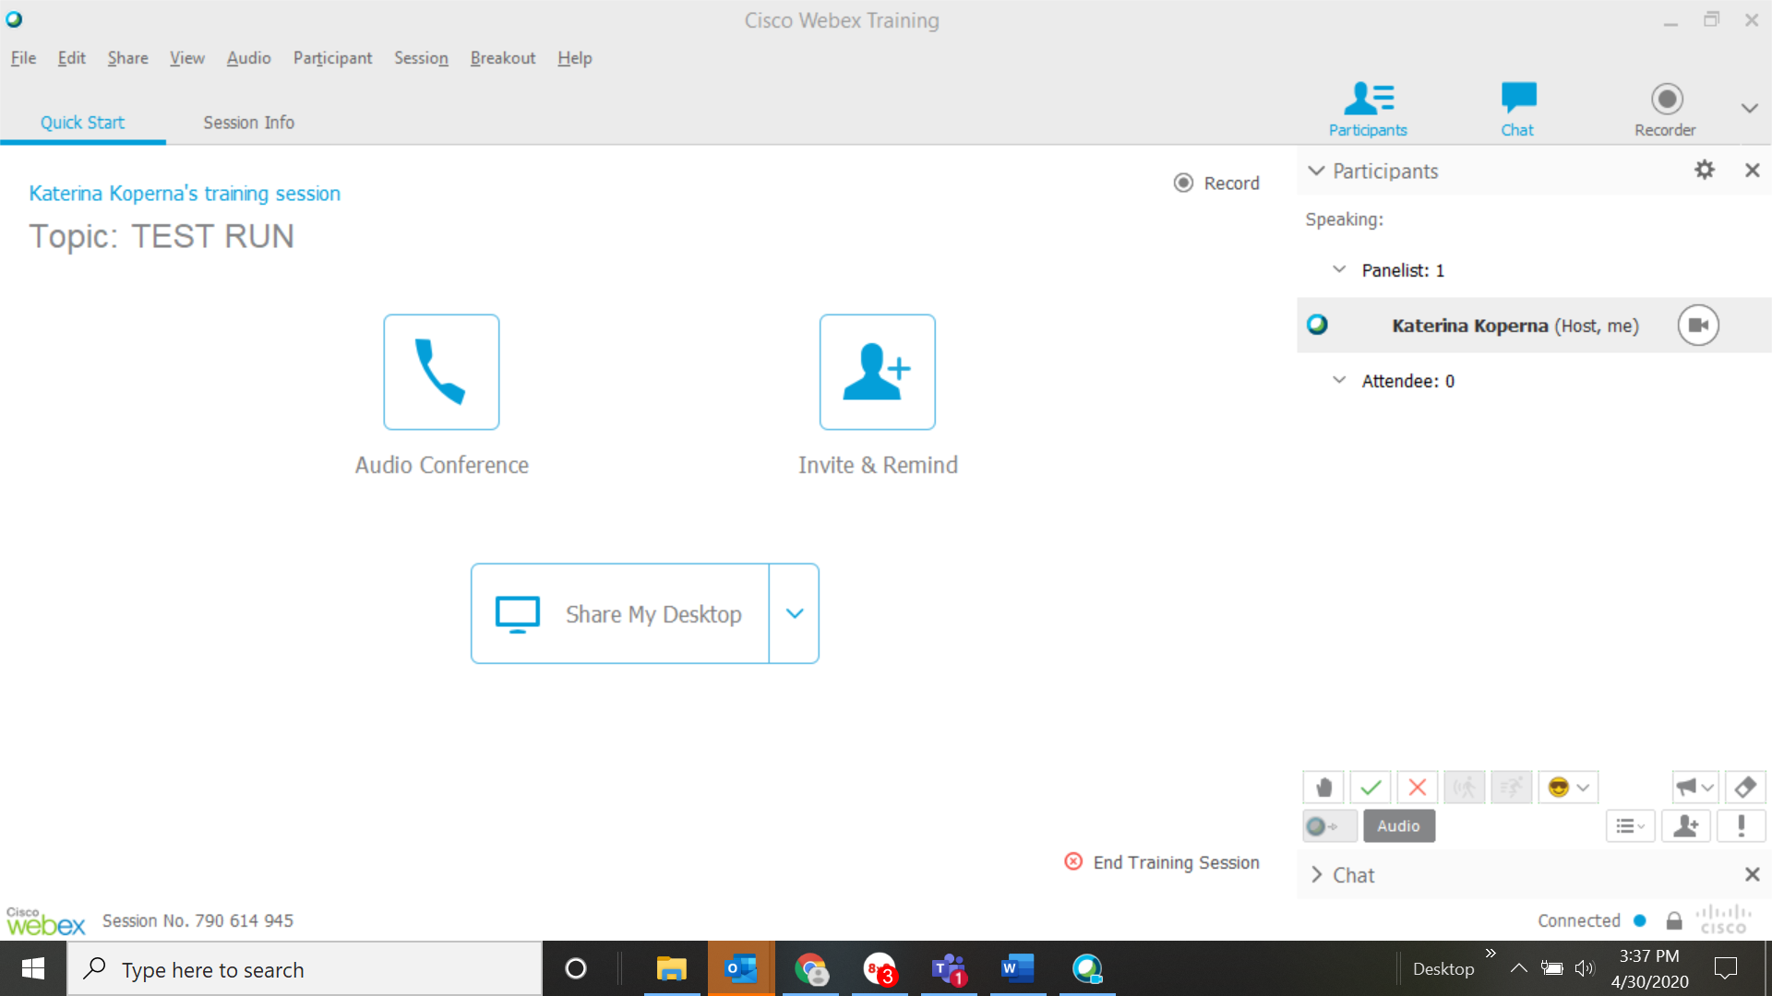  **OR** 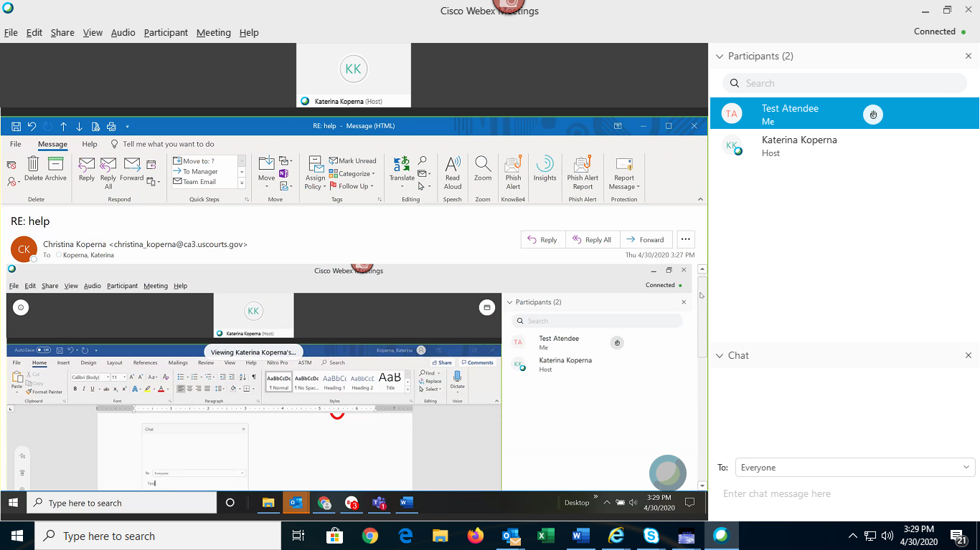

**SIGNIFYING AGREEMENT OR DISAGREEING WITH A TOPIC** – by selecting the green check mark you can indicate agreement or conversely, by selecting the red x you can indicate your disapproval



**For additional guidance and the most current information from WebEx, go to** [**https://help.webex.com/en-us/n62wi3c/Get-Started-with-Cisco-Webex-Meetings-for-Attendees**](https://help.webex.com/en-us/n62wi3c/Get-Started-with-Cisco-Webex-Meetings-for-Attendees)